EXPERIMENT 1

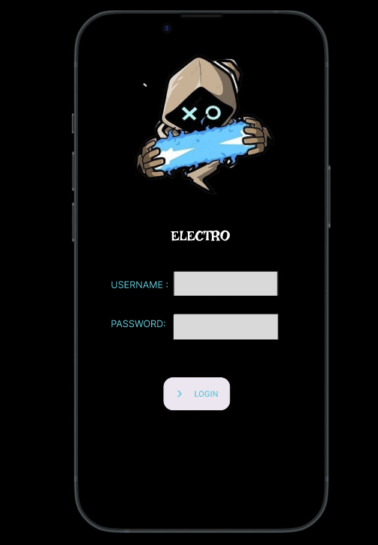

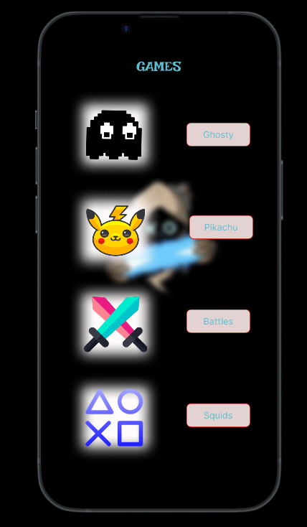

Link: https://www.figma.com/proto/y7licszsTuAFExr7urZye9/Untitled?node-id=1-2&p=f&t=zNemXG0CUwYPqSls-1&scaling=scale-down&content-scaling=fixed&page-id=0%3A1